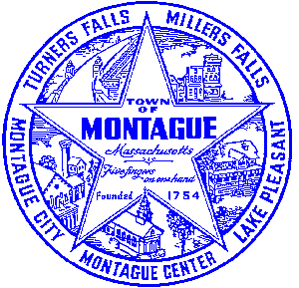
Town of Montague Municipal Airport Commission

Meeting Minutes
October 11th, 2023

The meeting was called to order at 5:35 PM in the administration offices.

Commissioners present: Gary Collins, Seth Rutherford, Joe Mazeski, Josh Lively
Others present: Bryan Camden (Manager) Dave D- Gale Associates

Review Meeting Minutes- Minutes of 8/8/23 and 9/12/23. No minutes are ready at this time. Tabled until the next meeting.

Consultant Report
1) Pioneer Aviation Ramp Replacement- EA Permitting: Stantect Contract Approval by Josh, second by Joe
2) Agreement for General Consulting Services- Gale Associates Approval by Joe, second by Josh

Manager Report
Review of the BIL submission for the terminal upgrade program. We have appliedfor $675,000 to replace windows, doors, HVAC, and roofing on the Pioneer Aviation Hangar. Also to increase ADA and community access. We should know in February 2024 if we were awarded the funding or not. Review and execute the 2024 USDA contract for wildlife services to commence December 2023 and conclude December 2024. Motion by Joe, second by Josh to execute the contract. Execute contract with Sandri Company for the replacement of the heating system in the maintenance hangar. Motion to execute by Seth, second by Josh. Brief review of the FACTS aviation program and the current status in regards to the town planning process and the new build timeline. Review the proposed newspaper publication for the rental of the Pioneer Aviation Hangar rear portion that will be vacated by hillside plastics. Reminder of the annual CIP meeting with FAA and DOT on October 12th, this is a zoom meeting. Review of the town project to do a wage and classification study for all town employees in FY24, results will be made public for review when completed.

Pilot, Tenant, Users Group, Public Comment, and Other
None
6:19 MOTION made by Josh to adjourn, second by Joe. All in Favor

Respectfully submitted: Bryan Camden

Voted ____ (Aye) ____(Nay) ____(Abstain) at an Airport Commission Meeting on: ____/____/______

_________________________
(Airport Chair Signature)

Documents used:
Manager's Report

