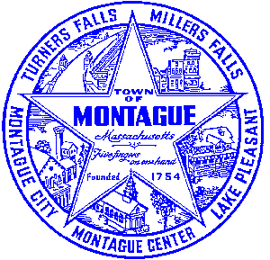
Town of Montague Municipal Airport Commission

Meeting Minutes
February 14th, 2023

The meeting was called to order at 6:32 PM in the administration offices.

Commissioners present: Gary Collins, Seth Rutherford (Remote), Joe Mazeski, David Brule, Max Pellerin (Remote)
Others present: Bryan Camden (Manager) Bob D- Stantec, Matt C- Gale Associates

Review Meeting Minutes- No minutes at this time to discuss.

Consultant Report
AIP 21- Wildlife Hazard Assessment Study- Continue to work with USDA contract services to meet our imidate needs.
AIP 23- Purchase Pioneer Aviation Property- There are no new updates on that project as of right now, reimbursement from the FAA is still pending at this time. MassDOT is seeking additional information that is missing / misplaced.
Pioneer Development Plan- 2023 will be the planning and tribal coordination period, 2024 will be the actual construction. Tribal coodination will be done via historical documents and or new findings.

Manager Report
Notes on the Eversource service changeover on the Pioneer Aviation Hangar. FCTS hangar beginning stages, discussion of grant, stages, project timeline, and ownership. Discussion of tree service truck parking in the main lot for 3-5 months. We will collect a fee for the parking services. Brief update on the land lease RFP for the north-east side of the airfield. Plan as of tonight is to have the land lease signed and awarded no later then May 1st 2023 with revenue starting in June 2023. Hangar storm damage update, we lost 9-18’ panels on December 23 2022 as the result of the major wind event. Repairs are now completed, but we will need to finish up in the summer. Remindere that we have our annual budget hearing on 2/22/23 via zoom with Fincom and BOS.
Commissioner Updates

Pilot, Tenant, Users Group, Public Comment, and Other
None
7:01 MOTION made by David to adjourn, second by Joe. David, Yes. Joe, Yes. Seth, Yes. Max, Yes. Gary, Yes. All in Favor

Respectfully submitted: Bryan Camden

Voted ____ (Aye) ____(Nay) ____(Abstain) at an Airport Commission Meeting on: ____/____/______

_________________________
(Airport Chair Signature)

Documents used:
Manager's Report

