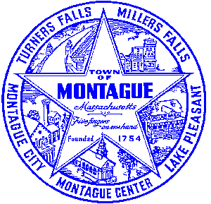
Town of Montague Municipal Airport Commission

Meeting Minutes
April 11th, 2023

The meeting was called to order at 6:31 PM in the administration offices.

Commissioners present: Gary Collins, Seth Rutherford, Joe Mazeski, David Brule,
Others present: Bryan Camden (Manager) Bob D- Stantec, Matt C, Dave D- Gale Associates

Review Meeting Minutes- Approve minutes of 12/13/22 and 2/14/23. Table to next Meeting

Consultant Report
AIP 21- Wildlife Hazard Assessment Study- Continue to investigate the permitting process, awaiting response from USDA.
AIP 23- Purchase Pioneer Aviation Property- There are no new updates on that project as of right now, reimbursement from the FAA is still pending at this time. MassDOT is seeking additional information that is missing / misplaced.
Pioneer Development Plan- Planning study and design will occur in summer / fall of 2023. Construction will be 2024.

Manager Report
Discussion and review of Operation Manager job description. Having no changes needed, a motion was made to adopt the new job description as is for the FY24 year. MOTION made by Seth, second by Joe. VOTE- All in favor. Eversource service changeover on Pioneer Hangar was completed, there are a few remaining items that need to be addressed including building grounding and meter installation. FCTS Aviation program is moving along. The building kit is on order, and construction is expected to begin in July of this year. Review of the potential to purchase a vehicle in fall 2023, potentially a car for transient pilot usage. We will revisit in the fall. Review of the FRCOG bulk fuel bid pricing for FY24, decision was to NOT join the bid due to the major price changes in the last 24 months. Discussion of the consultant selection process, external review team and the internal commission review team. Review of the 2 RFP responses for the solar development. MOTION to offer least to EDF renewable pending an executed lease agreement by Seth, second by David. All in favor. Discussion of tribal coordination for Pioneer Apron and FCTS hangar project. Bids were received from 2 firms for the test pit work at both locations. MOTION to award both test pit projects to PAL companies to commence as soon as funds are allocated made by Seth, second by David. All in favor.
Commissioner Updates
Request for donation of services (gators) and funds for the Montague Soapbox Derby. Sept 17th
Pilot, Tenant, Users Group, Public Comment, and Other
None
7:33 MOTION made by David to adjourn, second by Joe. All in Favor

Respectfully submitted: Bryan Camden

Voted ____ (Aye) ____(Nay) ____(Abstain) at an Airport Commission Meeting on: ____/____/______

_________________________
(Airport Chair Signature)

Documents used:
Manager's Report

