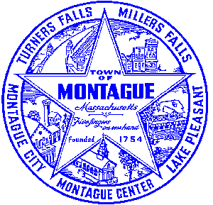
Town of Montague Municipal Airport Commission

Meeting Minutes
May 23rd, 2023

The meeting was called to order at 6:33 PM in the administration offices.

Commissioners present: Gary Collins, Seth Rutherford, Joe Mazeski, David Brule,
Others present: Bryan Camden (Manager) Randy C- Stantec, Matt C- Gale Associates

Review Meeting Minutes- Approve minutes of 12/13/22 and 2/14/23. MOTION to accept minutes by Gary, second by Joe. All in favor.

Consultant Report
AIP 21- Wildlife Hazard Assessment Study- No new updates at this time.
AIP 23- Purchase Pioneer Aviation Property- There are no new updates on that project as of right now, reimbursement from the FAA is still pending at this time. MassDOT is seeking additional information that is missing / misplaced.
Pioneer Development Plan- Planning study and design will occur in summer / fall of 2023. Construction will be 2024.

Manager Report
Reminder that 2 commission members have terms expiring at the end of FY23 and will need to be reappointed by the BOS and town clerk. FCTS Aviation update, no major changes to the project or timeline at this time. 2023 Mowing looks to be similar work area as 2021, and will be limited based upon staffing and if the ground get frozen over. In 2022 it never froze over enough to cut anything. Recap of our agreement with JaDuke and their sign placement on our fences. Review of summer staffing as we have one co-op student graduating and another taking a full ime job in Deerfield with the DPW. No action taken at this time. Warehouse repairs- There is some separation of the frost walls and the interior pad, likely due to settling of the building over time. We need to fill all cracks (approx 900’) with sealant and expanding foam then a top coat to keep any bugs out of the building. This will be done in house in the next few weekends when the shipper is closed. Transformer was replaced on the rotating beacon that had failed, approx $1500 in cost. Further discussion of consultant selection process. Execute land lease with EFD. Review of the annual town meeting, same questions as the last 3 years from some members, budget approved. Review of PAL proposed worksite for the FCTS aviation hangar location. Report to be sealed and not applicable for public review as it contains security related items. Copies to be provided to commission members. Review of the Airport Manager FY24 contract, discussion of the changes which included a wage line and a NOTAM authorization item line. David detailed some of the work related to the battlefield grant program that the MHC is working on.
Commissioner Updates
None
Pilot, Tenant, Users Group, Public Comment, and Other
None
7:30 MOTION made by David to adjourn, second by Joe. All in Favor

Respectfully submitted: Bryan Camden

Voted ____ (Aye) ____(Nay) ____(Abstain) at an Airport Commission Meeting on: ____/____/______

_________________________
(Airport Chair Signature)

Documents used:
Manager's Report

