- 6:30PM Call to Order
- 6:31 Approve Minutes of 4/11/23 and 5/23/23
- 6:35 Consultant Report – Votes may be taken
    - AIP 21- Wildlife Hazard Study
    - AIP 23- Pioneer Aviation Purchase Phase II Closeout MassDOT Documents
    - Pioneer Aviation Ramp Replacement- Planning Stage / Tribal Coordination
- 7:00 Managers’ Report – Votes may be taken
  - Monthly Report
    - Policy
A) None
    - Buildings and Grounds
A) FCTS Aviation Update- Review and Execute Land Lease Doc.
    - Other
A) Consultant Selection Reviews
B) Solar Development- New updates if any
C) CWF / Airport Collaboration
D) PAL Tribal Test Pits- FCTS Hangar (6-14 to 6-16)
E) Airport Manager Contract Discussion and Vote FY2024
F) Customer Appreciation Day / Cookout
    - Treasurer’s Report
A) Year Ending Totals
    - Tribal Update (David)
-

- 7:40 Pilot, Tenant, Users Group, and Public Comment; Other Business – Votes may be taken
  - Opportunity for the public to address the Commission
  - Any topics not anticipated in advance of the posting requirement

- 7:50 Commissioners Updates and Comments

Posted at Town Hall as indicated by the stamp above.
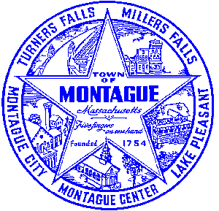
Posted on http://www.montague.net/f/75/Airport-Commission-Meetings on 6/9/2023 at 5:30pm

