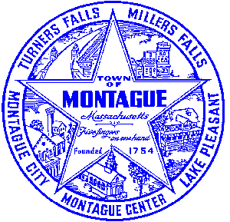
Town of Montague Municipal Airport Commission

Meeting Minutes
June 13th, 2023

The meeting was called to order at 6:30 PM in the administration offices.

Commissioners present: Gary Collins, Seth Rutherford, Joe Mazeski, David Brule, Max Pellerin (remote)
Others present: Bryan Camden (Manager) Pete E- Stantec, Matt C, Dave D- Gale Associates

Review Meeting Minutes- No Minutes were ready for review at this time.

Consultant Report
AIP 21- Wildlife Hazard Assessment Study- No new updates at this time.
AIP 23- Purchase Pioneer Aviation Property- There are no new updates on that project as of right now, reimbursement from the FAA is still pending at this time. MassDOT needs to process their PV’s now.
Pioneer Development Plan- Planning study and design will occur in summer / fall of 2023. Construction will be 2024.

Manager Report
FCTS Aviation Program- No new updates as of right now, utility connection work is ongoing and should start within the next 6 weeks. Consultant Selection- No new updates, still reviewing submissions. The airport will be working with the CWF to update the “airport” waste water lift station. This will be for the new hangar connection as well as any new development on that side of the airport. FCTS Hangar test pits will be done this week 6/14 to 6/16 and results will be presented to the commission once completed. Vote on the Airport Manager contract for FY24 MOTION to accept the contract made by David, second by Joe. All in favor.
Commissioner Updates
None
Pilot, Tenant, Users Group, Public Comment, and Other
None
7:03 MOTION made by David to adjourn, second by Joe. All in Favor

Respectfully submitted: Bryan Camden

Voted ____ (Aye) ____(Nay) ____(Abstain) at an Airport Commission Meeting on: ____/____/______

_________________________
(Airport Chair Signature)

Documents used:
Manager's Report

