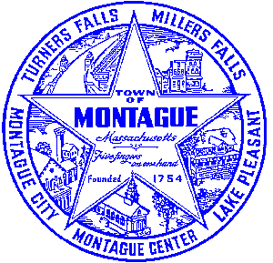
Town of Montague Municipal Airport Commission

Meeting Minutes
February 13th, 2024

The meeting was called to order at 6:30 PM in the administration offices.

Commissioners present: Gary Collins, Joe Mazeski, Josh Lively, David Brule, Seth Rutherford
Others present: Bryan Camden (Manager)

Review Meeting Minutes- Minutes of 11/14/23 and 12/19/23. Motion to approve minutes as produced by Josh, second by David. Motion passes all in favor.

Consultant Report-(Gale associates monthly report attached)
1) Pioneer Aviation Ramp Replacement- AIP 27-EA Stantec Project (No Updates Tonight)
2) FCTS Hangar project- No new updates to report, project closed out (Gale Report)
3) Pioneer Aviation Ramp Replacement- Design / Bid project discussion (Gale Report)

Manager Report
Review of new commercial non-aviation lease rates. Increased amounts to take effect May 2024, last increases was before we owned the Pioneer Aviation property. Vote to approve new New England Natural Bakers land lease for 2 years to commence March 1st 2024 and conclude March 1st 2026 at the new lease rate which is an increase of 4.5% over previous. Other non aviation users will remain month-to-month at their request.Discuss application for ASMP grants for: A new hangar door for the Pioneer Aviation Hangar, Security System updates, and equipment in FY24. BIL Airport Terminal Improvement program update, no news as of yet, expected listing to be updated and awards to be posted in late February 2024 last year they received 1.4 billion in request for a 900 million cap. Review of FY25 budget as proposed, MOTION to approve the FY25 budget by Gary, second by David. Vote- All in favor. Review of current vs proposed new revenues in FY25. Review of Pioneer Aviation debt service for FY25. AIP projects local, federal, and state share for FY25. Update on FY24 expenditures YTD.

Pilot, Tenant, Users Group, Public Comment, and Other
None
7:45 MOTION made by David to adjourn, second by Gary. Vote- All in Favor.

Respectfully submitted: Bryan Camden

Voted ____ (Aye) ____(Nay) ____(Abstain) at an Airport Commission Meeting on: ____/____/______

_________________________
(Airport Chair Signature)

Documents used:
Manager's Report
Gale Associates Report

