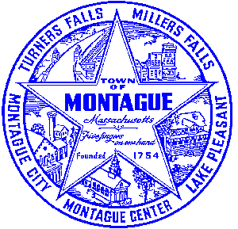
Town of Montague Municipal Airport Commission

Meeting Minutes
March 12th, 2024

The meeting was called to order at 6:32 PM in the administration offices.

Commissioners present: Gary Collins, Joe Mazeski, Josh Lively, David Brule, Seth Rutherford
Others present: Bryan Camden (Manager), Mark and Matt- Gale Associates

Review Meeting Minutes- Minutes of 2/13/24. Tabled at this time

Consultant Report-(Gale associates monthly report attached)
1) Pioneer Aviation Ramp Replacement- AIP 27-EA Stantec Project- First draft finally prepared
2) FCTS Hangar project- No new updates to report, project closed out (Gale Report)
3) Pioneer Aviation Ramp Replacement- Design / Bid project discussion (Gale Report)

Manager Report
Metting with Franklin County Radio Controlled Flying Club regarding new lease agreeemnt. Terms reviewed and discussed. They would like 5 years with right to renew, rates discussed. Motion to offer FCRCC a new lease with agreeded new terms to commence July 1st 2024 upon the club emailing to airport manager a list of officers and emergency contacts as well as updated emails and mailing address. MOTION- Gary, second by David. Vote- All in favor. Executed lease for NENB per discussion and their approval afte the last meeting with new rate increases. Begin discussion for land lease rate changes in January 2025. No siginficant changes are expected, however we should intend on discussion further in the summer months. Update on the BIL Terminal funding, we were not allocated any funds, and for the 3rd time the only airport in Massachusetts that was allocated any finding was Boston. They have received over 96 million YTD from the programs 3 allcation rounds, $0 has gone to any GA airport in the state. Brief discussion of the annual and special town meeting warrants, regarding airport funding articles.Update on YTD expenditures. Test pit program for the Pioneer Aviation property was completed. Report is still pending.

Pilot, Tenant, Users Group, Public Comment, and Other
None
7:35 MOTION made by David to adjourn, second by Josh. Vote- All in Favor.

Respectfully submitted: Bryan Camden

Voted ____ (Aye) ____(Nay) ____(Abstain) at an Airport Commission Meeting on: ____/____/______

_________________________
(Airport Chair Signature)

Documents used:
Manager's Report
Gale Associates Report

