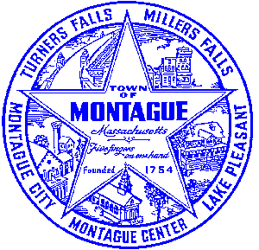
Town of Montague Municipal Airport Commission

Meeting Minutes
May 14th, 2024

The meeting was called to order at 6:30 PM in the administration offices.

Commissioners present: Gary Collins, Joe Mazeski, Josh Lively, Seth Rutherford
Others present: Bryan Camden (Manager), Mark and Matt- Gale Associates

Review Meeting Minutes- Minutes of 2/13/24 and 3/12/24. Tabled at this time

Consultant Report-(Gale associates monthly report attached)
1) Pioneer Aviation Ramp Replacement- AIP 27-EA Stantec Project- First draft review ongoing
2) FCTS Hangar project- No new updates to report, project closed out (Gale Report)
3) Pioneer Aviation Ramp Replacement- Design / Bid project discussion (Gale Report)

Manager Report
Review of the Airport Manager contract for FY25 with changes to dates and compensation, in line with what was approved at annual town meeting. This will be voted on at the June meeting. Continued review of all lease and usage rates for FY25 to take effect January 1st 2025. Updates provided on the Pioneer Aviation Hangar door replacement project. The warehouse sewer pump failed several weeks ago, the repair team found all 3 floats have failed over the past several years, and the pump for the most part was still in good working order. Two floats were to activate the pump, the third was for the alarm system. Recap of the annual town meting and any needed changes to the operational budget. A brief discussion of any needed FY25 projects, including the AIP ramp project. Update of FY24 expenditures YTD. Request from Montague Parks and Recreation for the use of handlead radios and John Deere gator for the annual soapbox derby on June 2nd. MOTION made by Joe, second by Josh. Vote- All in favor.

Pilot, Tenant, Users Group, Public Comment, and Other
None
7:06 MOTION made by Joe to adjourn, second by Josh. Vote- All in Favor.

Respectfully submitted: Bryan Camden

Voted ____ (Aye) ____(Nay) ____(Abstain) at an Airport Commission Meeting on: ____/____/______

_________________________
(Airport Chair Signature)

Documents used:
Manager's Report
Gale Associates Report

