- 6:30PM Call to Order
- 6:31 Approve Minutes of 8/13/24
- 6:35 Consultant Report – Votes may be taken
    - Pioneer Aviation Ramp Replacement Project
    - DBE Program Reporting
    - FCTS Hangar Pavement
- 7:00 Managers’ Report – Votes may be taken
  - Monthly Report
    - Policy
A) Wage & Classification Study Information
    - Buildings and Grounds
A) Pioneer Hangar Improvements- Door, Siding, Wastewater, HVAC
B) Pioneer Parking Lot
    - Budget Updates
A) Planning for FY26
B) Budget Message from Town
    - Treasurer’s Report
A) Updated Expenditures
    - Tribal Update (David)

- 7:30 Pilot, Tenant, Users Group, and Public Comment; Other Business – Votes may be taken
  - Opportunity for the public to address the Commission
  - Any topics not anticipated in advance of the posting requirement

Posted at Town Hall as indicated by the stamp above.
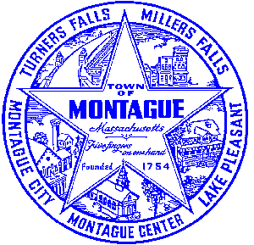
Posted on http://www.montague.net/f/75/Airport-Commission-Meetings on 11/06/2024 at 11:00am

