- 6:30PM Call to Order

- 6:40 Joint Meeting with Montague Selectboard to present quarterly Airport Update
    - Update on solar development
    - STM Fuel revolving account limit increase request
    - Review of non-town funded capital requests: FAA or DOT funding
    - Review of FY25 budget
    - Discussion on FY27 budget & revenue

Posted at Town Hall as indicated by the stamp above.
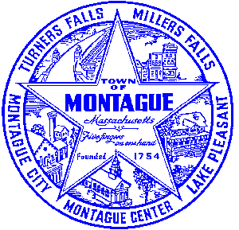
Posted on http://www.montague.net/f/75/Airport-Commission-Meetings on 07/30/2025 at 11:00pm

