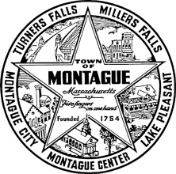
Montague Historical Commission
Board Meeting

Monday October 21, 2019
10:00 a.m. to 12:00 noon
Montague Town Hall 2nd floor conference room.
1 Ave. A, Turners Falls, MA

Agenda:

1. Welcome Chris Clawson as new MHC member.

2. Appoint/Elect Vice Chairperson in lieu of Mary Melonis retirement.
Appoint a temporary secretary until April Reipold returns from medical
sabbatical.

3. What physical boundaries encompass each of the five villages. Millers Falls
and Turners Falls are established.

4. Discussion pertaining to the Keith/Strathmore Paper Mill demolition/preservation and the Esleeck/Southworth pedestrian foot-bridge
demolition/replacement.

5. Establishing a meeting plan/schedule.

6. Montague Center road directory marker/kiosk. The possible addition of
the Turners Falls location/name.

7. Protocols for M.H.C. Meeting announcements/publications

8. Topics not anticipated within the 48-hour posting requirements:

9. Public comments.

Adjourn:

Notes:

